Automated Pneumonia Detection Using VGG19:
A Deep Learning Approach for Chest X-Ray Analysis

AKASH P V, ARYA T, MANIMOZHI R,
MCA Department, Aloysius Institute of Management and IT(AIMIT)

ABSTRACT
Pneumonia is still as deadly today as it was in the past and this explains why there is need to diagnose this illness as early as possible in order to minimize on the chances of death that may be associated with this illness. Recent advances in the field of machine learning (ML) show better results and potentials of intelligent computing approach to identifying and diagnosing cases of pneumonia. This review systematically summarizes and critically analyses the advanced ML methods that have been used to diagnose pneumonia. In detail, we are to describe the characteristics of the examined datasets employed for the study and how they are applied in the development of efficient models. Details of the machine learning methods of CNNs for image diagnosis as well as the methods like ensembling which are used for data fusion are explained. In addition, we discuss the precautions and considerations that are linked to the use of ML, such as quality data considerations, interpretability concerns, generalization concerns etc. To sum up, this review study will also strive to provide a comprehensive summary of current approaches, which is pivotal in filling the existing literature gap, and outlining the future research recommendations for enhancing the effectiveness of the ML-based systems for detecting pneumonia.

Keywords: Pneumonia detection, Chest -X Ray, VGG19, Model 1, Model 2, Model 3

1. INTRODUCTION
Pneumonia remains a leading cause of morbidity and mortality worldwide, particularly in children under five and the elderly. Advances in machine learning and deep learning techniques, especially Convolutional Neural Networks (CNNs), have now opened new ways to automatically detect pneumonia from medical imaging, specifically chest X-rays (CXR). This paper discusses the latest state of research in the detection of pneumonia, especially how machine learning methodologies have evolved, the role of CNNs in feature extraction, and the effectiveness of various models in enhancing diagnostic accuracy.
Recent progress in the use of CNNs for medical image analysis is highly driven by their capability to automatically learn and extract relevant features from raw image data. Traditional detection of pneumonia involving handcrafted features and traditional machine learning algorithms often requires significant domain knowledge and pre-processing. The rise of deep learning has shown that CNNs have superior automatic ability to identify complex CXR images with higher accuracy and efficiency.
This paper presents the most important works which contributed to the field. Key aspects and limitations of each method are presented, showing that examining such studies will be very informative to provide a full landscape overview and identify which research should be further carried out in order to enhance robustness and reliability in the models used for the detection of pneumonia.

Figure 2.1 Pneumonia
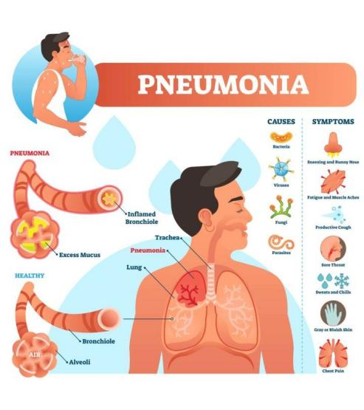

2.LITERATURE REVIEW
There is a research paper on pneumonia detection using the help of CNNs. Four different CNN models are presented which classify the chest X-ray images as normal or cases of pneumonia. Their training was performed on the dataset of 5856 images and the three evaluation metrics are: validation accuracy, recall, and F1 score. The best model having three convolutional layers provided validation accuracy of 92.31%, recall was 98%, and F1 score was 94%. In conclusion, it proves that CNN models may be applied effectively for the early detection of pneumonia and would help in reducing its mortality rates, especially for children. [1]

This research paper focuses on the use of supervised learning in the detection of pneumonia from chest X-rays. The paper explains how the diagnosis made by an X-ray is quite difficult compared with other forms of imaging. The authors, utilizing a large dataset of images from the NIH, totalling over 112,000, train a binary classification model to differentiate between pneumonia and no pneumonia cases.
First, logistic regression baseline is used that scores an AUC score of 0.60 but that is not acceptable as the data is pretty complex. Then, use a DenseNet convolutional neural network, and pushes AUC to 0.609 but fails to generalize well to the unseen data which may have caused due to class imbalance within the dataset.
Finally, the authors give some direction of future work like examination of various features, a better logistic regression baseline model, further error analysis with appropriate bounding boxes for improved pneumonia localization in X-rays. Finally, the authors credit their mentors and go to some extent in specifying all the contributions of the different authors towards the project in hand. [2]
The paper focuses on detection through the use of convolutional neural networks (CNNs) for chest X-ray images to detect pneumonia. High light is given to correct diagnosis as in cases where a child or an elderly person is concerned, as this is extremely sensitive. Several CNN architectures were looked at for this purpose to be able to evaluate and pinpoint which one would best fit in classifying X-rays as either pneumonia-positive or not.
The authors use the same dataset with normal and pneumonia-affected image cases. Performances are compared for configurations of CNNs with performance metrics that include maximum validation accuracy as well as lowest validation cross-entropy loss. These results indicate that more straightforward architectures for CNNs allow more easily developed models to also have a comparable level of accuracy but lower computational costs. Models like these are more applicable to medical use.
Finally, the paper concluded that CNNs appear promising for detection of pneumonia but further investigation in fine-tuning such a model would likely improve the specificity and the speed of using CNNs in clinical. [3]

In this paper, discussion of machine learning classifiers to identify pneumonia through chest X-ray images was done. This was aimed at early diagnosis for effective treatment and an effort in developing an automated system that would help medical practitioners diagnose.
The authors utilized another machine learning technique-applied to classify X-ray images, ranging from normal to pneumonia-affected conditions-with a different technique of seven in total, the CNN. Using these preprocessors and with models of CNN trained on 5,856 images, CNN was the most accurate form of classification, which the comparison with traditional ML resulted in 98.46%.
The paper concludes that deep learning techniques, especially CNNs, significantly enhance the accuracy in the detection of pneumonia with chest X-rays, promising their utility as a new diagnostic tool in clinical work. Future work will further improve model performance and grow the dataset for better generalization. [4]

The proposed work is on applying machine learning algorithms, particularly CNNs, for automatic detection and classification of pneumonia based on chest X-ray images. It will try to show that early detection and classification of the disease help improve conditions for the patients, more so from the resource poor settings.
The authors consider a CNN model in evaluating whether chest X-ray images are positive or negative for the presence of pneumonia. Then, they show the results on accuracy, sensitivity, and specificity measures. Thus, this could be another deep learning-based approach that can also enhance pneumonia detection, making this technique even more useful in health care practice.
It concludes that though promise there is in the system, a crucial need still for research and validation in the area of reliability and its practicality for clinical applications lies ahead. [5]

The research paper presents a convolutional neural network (CNN) model to classify chest X-ray images as either normal or pneumonia-affected. The authors use a dataset from the NIH Chest X-ray Dataset and perform data augmentation to increase the number of images. They experiment with various CNN architectures, such as ResNet-50 and DenseNet-121, and compare their performance. The best-performing model is a modified DenseNet-121, which achieves a validation accuracy of 95.3%. The authors also compare their results with previous studies and discuss the limitations of their work, such as the class imbalance in the dataset. Overall, the study demonstrates the potential of deep learning models in medical image analysis. [6]

Highlights
1.The best CNN model was at an accuracy of 92.31% on validation, having a recall of 98% and F1 score of 94%. This depicts the capacity of CNNs in the early detection of pneumonia, especially in children.
2. The baseline was a logistic regression model, which resulted in a poor AUC score of 0.60. The DenseNet CNN increased the AUC to 0.609 but suffers from poor generalization towards unseen data due to the class imbalance in the data set.
3. The paper discusses several architectures of CNNs and comments that the simpler models might have higher accuracy at the cost of lower computational effort, making them more appropriate for medical applications.
4.With a modified DenseNet-121, the validation accuracy was obtained as 95.3%. The authors have augmented the data and compared with previous studies. The major limitation has been class imbalance.
5.accuracy 98.46% by CNN model in comparison with traditional methods, the work emphasizes the application of deep learning techniques as powerful diagnostic tools in clinical settings.
6.The study has highlighted the need for early and precise diagnosis for improvement of the patient and also asserted that although the proposed CNN system has tremendous potential, more research and validation are necessary before reliable clinical application can be considered.

3.METHODOLOGY
This paper will clearly outline the processes and techniques used in the building and evaluation of a pneumonia detection system. With this clear and detailed explanation, readers will understand why certain methods were selected, and it will be easier for them to replicate the study for further validation or improvement.

Figure 4.1 Working

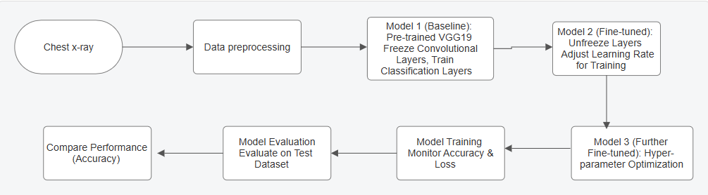

3.1. Data Collection
This dataset was fetched from the Kaggle repository in the form of chest X-rays belonging to "Normal" and "Pneumonia." Since there were class imbalances that would result in biased outcomes, it was curated so that both classes had equal numbers of images in each category. Pre-processing: Input Images size has been altered as it can now be taken on VGG19 model for which the sizes of all image have been made same for 128*128 while pixel values scaled into [0, 1] range taken from the scale [0, 255] gives faster convergence due to steady scaling. Then, data augmentation technique was applied on the tool ImageDataGenerator for random rotations, flips, zooms, and shifts, which artificially enhance the diversity of a dataset, and thus, there is a reduction in the chances of overfitting. The dataset was split into 80% as the training and 20% for testing to conduct the robust evaluation.

Figure 4.1.1 NORMAL Figure 4.1.2 PNEUMONIA
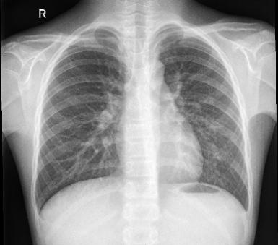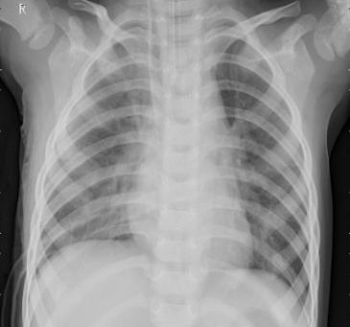

3.2 VGG19 Architecture
The VGG19 architecture is a deep convolutional neural network, which has been developed for image classification tasks and can be successfully applied to other computer vision problems, like pneumonia detection from chest X-ray images. It comprises 19 layers, where 16 are convolutional layers and 3 fully connected layers. Convolutional layers are grouped in five blocks, and every block is followed by a max-pooling layer. This enables these layers to pull hierarchies of features from a simple image from edges all the way up to a more complex form and to objects. A convolutional layer of VGG19 comprised filters of 3 x 3 and a layer pool with the filters of 2 x 2 that spatially reduces the features. So, it retains small information features from those hierarchies and minimizes their computer-intensity intensity.
In addition to this, the output or culminating of the network involves fully connected layers. In return, these comprise all features learned by convolutional layers to output a final classification. The probabilities of each class's outputs from every unit of the final output layer would be produced upon applying the softmax activation function to the final fully connected layer. This will "correspond to" "normal" and "pneumonia" in our case. Nonlinearity is introduced with VGG19 by using ReLU activation across the convolutional layers. This version of VGG19 doesn't have much depth in comparison to the original VGG because many applications today require fine-tuning a model that already well understands complex features, as proven by the depth.
Using the model, it provided the application of VGG19; this is pre-training had been done on it since it's trained from large amounts of images within ImageNet before fine-tuning it for the pneumonia set. VGG19 may successfully detect signs of pneumonia through transferring the weights learned from the ImageNet into pneumonia. Model 1 is the baseline model of VGG19, where classification layers are used; whereas Model 2 and Model 3 are fine-tuned models, and Model 3 further refines the hyperparameters for better accuracy in the methodology. The capability of VGG19 as deep architecture along with transfer learning makes it a potential candidate for the detection of very subtle signs of pneumonia in chest X-ray images, which led to the high accuracy of your research.

3.3 Models
Model 1 is the baseline model for the detection of pneumonia using the VGG19 architecture. It utilizes a pre-trained VGG19 model, which was trained on the ImageNet dataset to classify images in general. The classification layers were then added on top of the VGG19 network in order to classify chest X-ray images to detect pneumonia. Used: This model applies pre-trained ImageNet weights and trains primarily the newly added classification layers in the model, with their convolutional layers frozen just to retain their prelearned features. This is to begin with a model whose performance can be tested, so as to know the ability of VGG19 with pneumonia classification. It gets trained using the categorical cross-entropy loss function accompanied with the SGD optimizer.
Model 2 consists of Model 1 extension, which utilizes fine-tuning. Certain layers are allowed to be trainable from this pre-trained VGG19 model. The two enabled convolutional layers are block5_conv3 and block5_conv4 since they are more deep in the network. In such layers of the network, more advanced abstract features learned from what was inputted into them. Unfreezing of those layers helps Model 2 adjust the VGG19 model so that it more efficaciously learns task-specific features used to identify pneumonia. The actual training procedure in fine-tuning involved setting a lower learning rate of updated layers to avoid ruining their pre-learned characteristics. This change facilitates fine-grained information concerning how the model is performing during detection.
Model 3 better than Model 2 are more tuning to perform better: further fine-tuning layers optimization of hyperparameters or learning rates, batch size, and epochs configurations. Here, the hope is that by fine-tuning the configurations, improvements in the model's capacity to generalize on new, yet unseen data can be achieved. Hyperparameter adjustments, such as learning rate schedules or early stopping, could prevent overfitting and ensure that the model would work well on both training and validation datasets. This is an iterative improvement of Model 2, which works toward the best possible accuracy for the detection of pneumonia.

4.RESULT ANALYSIS
This analysis aims at assessing how effective these models are for detecting pneumonia by the use of chest X-ray images based on the VGG19 architecture. The objective here is to verify the correctness of how these models classify images into either "normal" or "pneumonia." In this section, we are comparing the training and validation accuracy, tracking the loss trends, and checking the overall performance of the three models: Model 1, Model 2, and Model 3. From this, we will be able to determine which model is the best and also what effects the changes and fine-tuning made in training had.
1. Training Accuracy:
The stability of the accuracy for epochs is fairly good as shown by Model 3, where, initial approximated accuracy is around 92.23 and then further on, achieves an accuracy close to 96.82 percent.
The rise in accuracy compared to previous models may not be sharp in most of the epochs of both models: 1 and 2 and much later epochs Model 3 should be more accurate.
2. Training Loss:
At each iteration, the training loss of Model 3 is lesser than that of Models 1 and 2. Generally, it would imply that the model has smaller training loss whenever it can fit the data on which it has been trained better.
Low training loss might also mean that the models are fitting the data less efficiently as Model3
3. Validation Accuracy and Loss:
If you also measure models against your validation accuracy and validation loss, then the best model most probably will be the one that has the highest validation accuracy and the lowest
validation loss.
Model 3 seems to have a good balance between training and validation performance according to the metrics. If the validation accuracy is also high and close to the training accuracy, it may be an indication that the model generalizes well to unseen data.
4. Early Stopping:
The Model 3 uses early stopping quite well where the training is stopped at epoch 16 which helps in not overfitting since it stops when the performance levels off.
According to the comparison of accuracy, loss, and mechanism of early stopping, Model 3 will most probably be the best model. Good training performance indicates that it generalizes very well to unseen data as pointed by the validation performance.

4.1 Comparison Among Models Based on Training, Testing and Validation
1. Compare the performance of the trainings: Decide which model has a high training accuracy and has a low training loss.
Model 3 has the maximum training accuracy as evaluated by the metrics
2. Compare the validation performance: Determine which model has good validation accuracy criterion and has least validation loss criterion.
If Model 3 also does the best validation accuracy as well as the lowest validation loss, then it is neither overfitting and very well generalizes to unseen data.
3. Compare Test Performance: Finally, compare the test accuracy and test loss. The best model should be the one that eventually comes out as the strongest and most effective in practical applications.

Table 5.1.1 Comparison among models
Model | Training Accuracy | Training Loss | Validation Accuracy | Validation Loss | Test Accuracy | Test Loss
Model 1 | 0.8768 | 0.2874 | 0.6250 | 0.7173 | 0.8061 | 0.4293
Model 2 | 0.9206 | 0.1931 | 0.6875 | 0.5337 | 0.8750 | 0.3490
Model 3 | 0.9682 | 0.0963 | 0.8750 | 0.2664 | 0.9000 | 0.2600

Figure 5.1.2 Test accuracy comparison
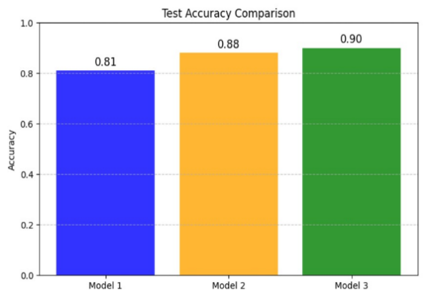

4.2 Training Parameters Explanation
1.SGD: SGD optimizer is used in each iteration of training that updates the model weights. It calculates the gradient of the loss function with respect to the model's weights and then updates the weights in a manner such that the loss along that direction is minimized.
SGD is probably the most widely used deep learning optimization algorithm. It's efficient and simple. The update steps of weights are minimized especially when the size of the data set is huge, so convergence can be achieved much faster.
2. Loss Function: Categorical Cross-Entropy For multi-class classification problems, the loss function categorical cross-entropy will be used. It measures how well the model's output actually matches the true labels through computing log loss for each class by measuring the difference between the true class probabilities and true class labels.
Since this is a binary classification task (normal vs. pneumonia), categorical cross-entropy is appropriate since it makes the model penalize by a higher amount for being wrong, thus helping in faster learning.
3. Learning Rate: Learning rate determines the step-size during weight update. Whereas high learning makes training pretty fast, there is always a possibility of overshooting the best solution. In low learning, very small steps are taken; hence the outcome is stable but slow learning.
It plays a very important role as the choice of the learning rate will decide how fast the model will learn. Taking too large a value for the learning rate makes the model not converge. A too low value considered might make the model converge slowly and sometimes even get stuck at the local minima.
4. Batch Size: 32
It is called batch size, which is the number of samples propagated through the network before the weights get updated. So if the batch size is 32, then it's updating at every 32 samples.
A batch size of 32 is normally assumed to be a reasonable trade-off between memory use and computation efficiency; this way, the model learns on a fairly sized amount of data at each step, but is not fitted too closely to noise as in the case with very small batch sizes.
5. Epochs: 50
An epoch implies passing over the entire set of training data once. So therefore, 50 epochs mean seeing your dataset 50 times through your model. Normally, an epoch has some iterations that may constitute different kinds of batches of data which it processes in the course of that iteration.
It was a number of experiments that came out and also from how the model was trained to learn. At least, usually the model keeps gaining in accuracy with each epoch until learning starts to over-fit on the training data; that's why 50 was taken, to balance that without providing too much fitting.

5.CONCLUSION
This work performed an analysis into the application of the VGG19 architecture in deep learning for automatically ascertaining the presence or absence of pneumonia from chest X-ray images. Exploiting some 5856 images in the dataset categorized to "normal" and "pneumonia" classes, models were generated and fine-tuned to achieve high precision. Among these three models, Model3 has been the best one, with 96.82% as the training precision and 87.50% as that of the validation, the most reliable out of all that could provide a clear distinction between a normal and pathological lung.
The results are verified so that deep learning approaches achieve better diagnostic outcomes in the sense of accuracy, like the use of a pre-trained architecture such as VGG19. Such proposed models will hopefully work from building a basis, from where suitable application and proper transfer learning or fine-tuning techniques may aid in getting integrated AI-based tools into the medical diagnostic tools. Considered as further work-testing for robustness of a model on many datasets with real-world implementations in a clinical environment along with its possibly generalized approach for detection purposes of other diseases of thorax. This study has proven that AI is transformative in solving health-related problems and changing the outcome of patients.

6.REFERENCES

[1] Kaushik, V. S., Nayyar, A., Kataria, G., & Jain, R. (2020). Pneumonia detection using convolutional neural networks (CNNs). In Lecture notes in networks and systems (pp. 471–483). https://doi.org/10.1007/978-981-15-3369-3_36

[2] Detecting Pneumonia in Chest X-Rays with Supervised Learning. (2021). .

[3] GM, H., GM, GOURISARIA, M. K., RAUTARAY, S. S., S., PANDEY, M., & siddharthfcs@kiit.ac.in. (2021). PNEUMONIA DETECTION USING CNN THROUGH CHEST X-RAY. In School of Engineering, Taylor’s University & School of Computer Engineering, KIIT Deemed to be University, Bhubaneswar, Odisha, India, Journal of Engineering Science and Technology (Vol. 16, Issue 1, pp. 861–876).

[4] Mamlook, R. E. A., Chen, S., & Bzizi, H. F. (2020). Investigation of the performance of Machine Learning Classifiers for Pneumonia Detection in Chest X-ray Images. Investigation of the Performance of Machine Learning Classifiers for Pneumonia Detection in Chest X-ray Images. https://doi.org/10.1109/eit48999.2020.9208232

[5] Bhattarai, P., A, V. K. K., Th, B., & Od, R. (2023). Detection of Pneumonia using Machine Learning. Detection of Pneumonia Using Machine Learning. https://doi.org/10.1145/3647444.3652464
[6] Kareem, A., Liu, H., & Sant, P. (2022). Review on Pneumonia Image Detection: A Machine Learning Approach. Human-Centric Intelligent Systems, 2(1–2), 31–43. https://doi.org/10.1007/s44230-022-00002-2

